IDEATION PHASE
Brainstorm & Idea Prioritization Template
Date | 31 January 2025
Team ID | 6ab221341
Project Name | Implement Client Script & UI Policy (Incident)
Maximum Marks | 4 Marks

Brainstorm & Idea Prioritization Template: Brainstorming provides a free and open environment for identifying possible solutions to a problem. For this ServiceNow project, the team brainstormed different ways to improve the Incident form using Client Scripts and UI Policies. The ideas were then grouped and prioritized based on their importance and feasibility.
Reference: MURAL – Brainstorm and Idea Prioritization Template (https://www.mural.co/templates/brainstorm-and-idea-prioritization)
Step-1: Team Gathering, Collaboration and Select the Problem Statement
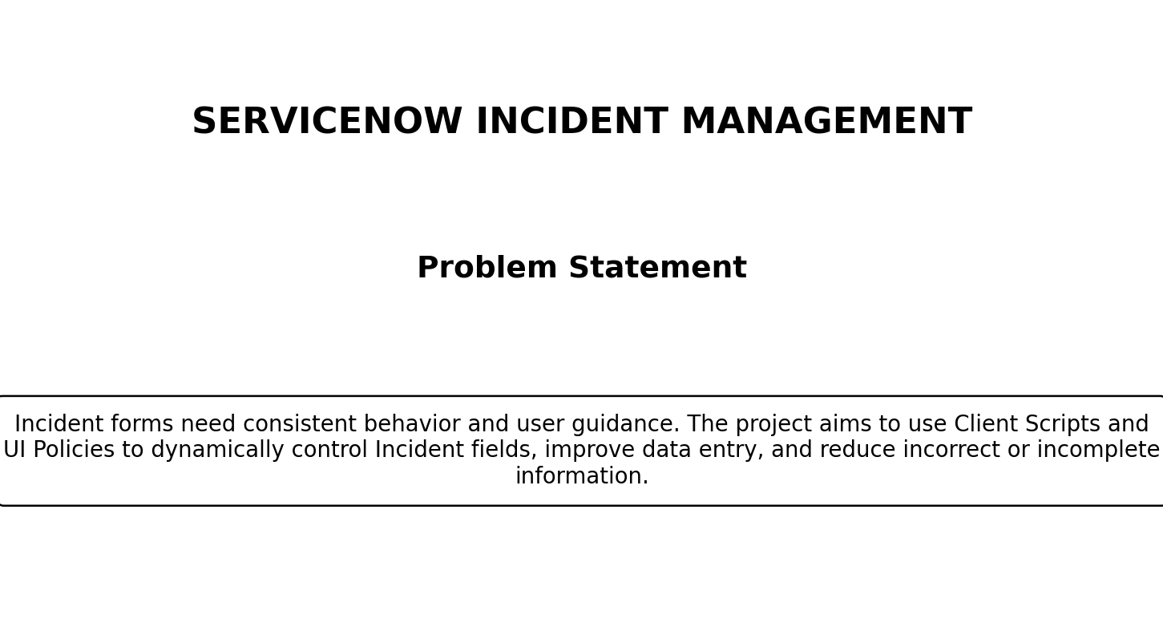
Problem Statement: Incident records in ServiceNow may require dynamic form behavior such as making fields mandatory, read-only, visible or hidden based on field values and form conditions. Without appropriate Client Scripts and UI Policies, users may enter incomplete or inconsistent incident information. The project therefore focuses on implementing Client Scripts and UI Policies on the Incident table to improve form behavior, validation and data quality.
Step-2: Brainstorm, Idea Listing and Grouping
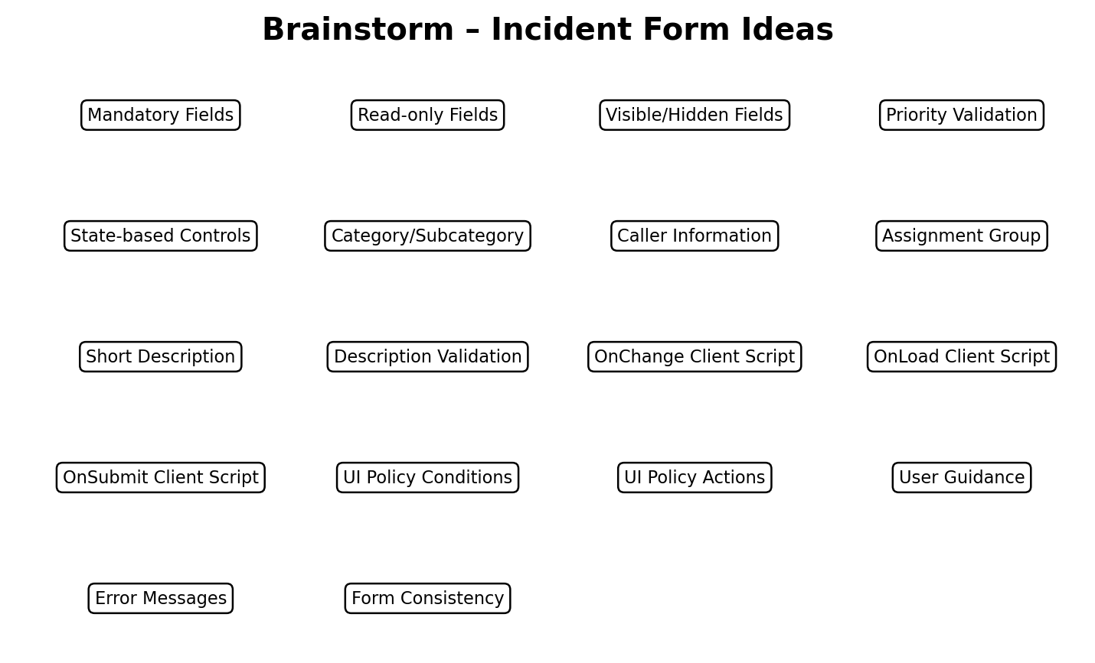
The team identified the following possible requirements and implementation ideas:
Group | Ideas
Client Scripts | onLoad, onChange and onSubmit scripts; field validation; dynamic messages
UI Policies | Make fields mandatory, make fields read-only, show/hide fields based on conditions
Incident Fields | Caller, Category, Subcategory, Priority, State, Assignment Group, Short Description, Description
Validation | Mandatory data checks, priority-related validation, incomplete information prevention
User Experience | Clear form behavior, user guidance, consistent Incident form interaction
Data Quality | Prevent invalid/incomplete submissions and maintain consistent Incident records

Step-3: Idea Prioritization
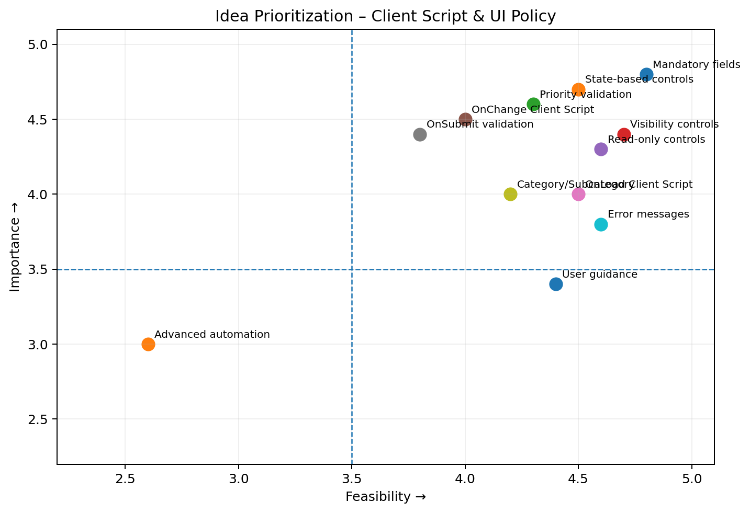

The ideas were prioritized using an Importance-versus-Feasibility matrix. Importance indicates how strongly a feature contributes to correct Incident management, while feasibility indicates how practical it is to implement using ServiceNow Client Scripts and UI Policies.
The core implementation focuses on mandatory-field control, state-based behavior, priority validation, visibility and read-only controls, and Client Scripts for onLoad, onChange and onSubmit behavior. These functions directly support the project's objective of improving Incident form validation and user interaction.
Expected outcome: a more consistent Incident form in which fields respond appropriately to user selections and form conditions, required information is captured, and invalid or incomplete submissions are reduced.

